1.2.1. General information on Zakarpatska area
Zakarpatska area is situated in the south west of Ukraine. It borders on Poland, Slovakia, Hungary and Romania as well as Lvivska and Ivano-Frankivska oblasts of Ukraine.
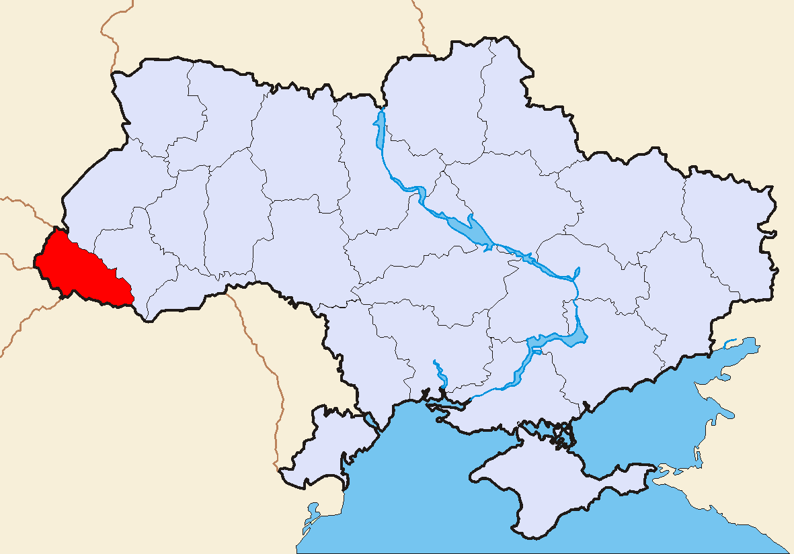

By its administrative and territorial system Zakarpattya is divided into 13 districts, 11 towns, 5 of them are of regional subordination, 19 urban-type communities and 307 village councils. There are 609 inhabited localities in the oblast, 193 of which have the highland status. The length of its territory from the West to the East makes up 184 km, from the North to the South – 80 km. Its regional centre is Uzhhorod, situated at 788 km highway distance and 898 km railway distance from Kyiv.
The area of Zakarpattya makes up 12,800 km² or 2.1% territory of Ukraine. The area of the region is 1.7 times smaller than any average oblast of Ukraine, almost 3 times smaller than the biggest region by its area Odeska oblast (33,300 km²) and slightly bigger than the smallest by its area Chernivetska oblast (8,100 km²). According to the data of 01/01/2005 its population accounts for 1,254, 614 people, that is 1.4 times less than any average oblast of Ukraine has. In total, 2.6% Ukrainian population live in Zakarpatska oblast. People mostly reside in Donetska (4.6 million people), the least – in Chernivetska oblasts (0.9 million people).
About 80% territory of the region is covered by mountains, where the highest peak of Ukraine – the Hoverla Mountain (2061 m) belongs to.
The longest river of Zakarpattya is Tisa. It runs through 223 km in the region. Besides, Tisa there are three more rivers in the region with length over 100 km (the rivers Uzh, Latorytsya, Borzhava). The largest lake is the lake Sinevir that emerged 10 thousand years ago at the height of 989 m above sea level. Its area is 7 ha, depth - 27 m, water temperature – from +12° up to +18°.
The main inhabited localities of Zakarpatska oblast
Regional subordination, population | District subordination, population | Urban-type villages – district centres, population
Uzhhorod - 118,000  Mukachevo – 83,000  Khust – 32,000  Beregovo – 26,000  Chop – 9,000 | Vynogradovo – 27,600  Svalyava – 18,100  Rakhiv – 15,200  Tyachevo – 11,500  Irshava – 10,200  Perechyn – 7,400 | Mizhgirya – 12,200  Volovets – 7,100  Velykyy Bereznyy – 7,000
Population of the region is characterized by its multinational composition. According to the All-Ukrainian Census of 2001 over 100 nationalities and ethnic groups live in the oblast. Its major part is formed by Ukrainians (80.5%), considerable part – Hungarians, Romanians, Russians, Slovaks and Romas. Zakarpattya is not only a multiethnic but also a multiconfessional region.
Educational attainment of population is rather high. It is secured by a manifold network of higher, professional and secondary educational institutions. At the beginning of the academic year 2005/2006 27,100 students studied in 19 institutions of higher education of the І-ІІ and ІІІ-ІV accreditation levels, including 1,500 students – in 5 private institutions.
The network of the institutions of higher education was expanded in the oblast in 2005. The geographic faculty and other new professions were introduced at Uzhhorod National University – ‘geography’, ‘land management’, ‘tourism’ and ‘nucleus physics’; in Zakarpattya State University – ‘banking’, ‘programming for computer-based systems’ and ‘international business’.

